Drone-Assisted Disaster Relief
Computer Vision-Powered Aid Delivery
First Author¹[0000-1111-2222-3333] and Second Author²[1111-2222-3333-4444]
¹ Princeton University, Princeton NJ 08544, USA
² Springer Heidelberg, Tiergartenstr. 17, 69121 Heidelberg, Germany
lncs@springer.com
Abstract. The Autonomous Aerial Humanitarian Assistance and Disaster Relief(A2-HADR) System aims to revolutionize disaster management by leveraging the capabilities of drones equipped with artificial intelligence (AI) to provide rapid and effective assistance in severe earthquake and flood situations. This innovative system integrates cutting edge Computer Vision technologies to automatically detect human beings and Objects/Obstacles from altitudes of 50-100 meters above the ground at slanted angles and deploy essential payloads, such as food, clothing, and rescue tools, to assist those in need.
Keywords: 1. Autonomous 2. Drone 3. Disaster Relief 4. Computer Vision
- Introduction
Floods are widely recognized as one of the most common and economically devastating natural disasters globally, frequently causing the greatest loss of life when compared to other calamities. The intensifying effects of global warming are anticipated to exacerbate the frequency and severity of flood events in the future. Categorized into flash floods, river plain inundations, and coastal floods, these disasters necessitate comprehensive flood management strategies spanning prevention, preparedness, response, and recovery phases.

Traditional flood management strategies include both structural and non-structural methods, such as building artificial structures like dams and embankments, as well as implementing floodplain zoning and early warning systems. Timely and precise data is crucial for successful flood management, leading to the development of remote data collection and automated interpretation technologies.

Automated Computer Vision, a branch of Artificial Intelligence, has become a key asset in flood management by providing automated interpretation and analysis of visual data.A variety of flood management tasks can benefit from the use of computer vision technology. These tasks include assessing flood risks, monitoring in real-time, measuring surface water velocity, creating flood models, mapping inundation areas, managing debris, and assessing damage after a flood event. However, despite some progress, the full potential of computer vision in flood management is still largely unexplored when compared to its applications in other fields. Therefore, it is crucial to evaluate the advantages of computer vision approaches in comparison to traditional monitoring methods in order to fully harness their trans-formative capabilities in flood management.
In this context, our proposed Autonomous Aerial Humanitarian Assistance and Disaster Relief (A2-HADR) System, leveraging advanced computer vision techniques, emerges as a promising solution. By integrating state-of-the-art object detection algorithms with drone technology, our system aims to revolutionize disaster response efforts, offering swift and targeted assistance during flood events. Through real-time detection and precise payload delivery, the A2-HADR System is poised to overcome the limitations of conventional flood management approaches, marking a significant advancement in disaster relief technology. Our Objective : Our objective in this idea is to create a system integrates cutting-edge Computer Vision algorithms and models to automatically detect human beings from altitudes of 50-100 meters above the ground at slanted angles.

Proposed Solution Our proposed solution integrates YOLOv8/v9, an advanced object detection algorithm, with drones for efficient disaster relief. YOLOv8/v9 real-time capabilities enable accurate detection of humans in crisis situations, guiding drones to drop aid precisely. This fusion of AI and drone technology promises swift and targeted humanitarian assistance during emergencies.

Realization of the Idea : The A2-HADR System comprises several key components, including drones equipped with high-resolution cameras, a robust processor board (such as Raspberry Pi or Intel NUC), sophisticated AI algorithms, and a payload dropping mechanism. Through real-time object recognition powered by AI, the system can identify individuals requiring assistance a midst disaster stricken areas. Upon detection, the system triggers an automatic alarm, alerting rescue teams to the location of the individual in distress.

Social Relevance and Impacts : The development of the A2-HADR System represents a significant advancement in disaster management technology, offering a versatile and scalable solution that can be deployed in a wide range of scenarios, including civilian applications and military operations.

The system boosts the efficiency and effectiveness of disaster response efforts by automating crucial tasks like object recognition and payload delivery, leading to saved lives and reduced impact of natural disasters. With its potential to revolutionize humanitarian assistance and disaster relief operations, the A2-HADR System holds immense promise for DRDO projects and civilian applications alike. By harnessing the power of AI and drone technology, this innovative system exemplifies the Ministry of Defences commitment to leveraging cutting edge solutions for the greater good of society, particularly in times of crisis.

2 Literature Survey

Several Computer vision methods have been suggested for comprehending and evaluating damages in flood situations. Witherow et al. [1] present an image processing pipeline to detect water levels on submerged streets using image data captured and generated by mobile consumer devices (e.g., smart-phones). However, their approach relies on pre-flood images to identify flooded areas using location-matched dry/overwhelmed condition image comparisons. Chaudhary et al. [2] propose a system to predict water levels from virtual simulation images, but it cannot provide real-time assessment due to the delayed availability of images/data through online simulation. Vitry et al. [3] propose a method that provides subjective flood level trend information at scale from fixed surveillance camera systems. However, this approach is limited to specific locations where cameras are installed. Although some studies analyze the flood situation using aerial images taken from remote satellites [4] [5], the extracted information is macroscopic and hardly in real-time. In [2], an approach is suggested for evaluating the water level from online simulation images using multitask learning.

The flood assessment is characterized as a regression issue for each image, which results in a loss of multiple images for the labeling system. Although this approach reduces the clarity of the explanation, it provides a rough estimation of the water level. However, it can only be applied in the specific region where the images are captured, limiting its widespread adoption. In a study conducted [6], flood-related images from online entertainment platforms were analyzed to classify them into three severity classes: not flooded, water level under 1 meter, and water level over 1 meter. Two convolution neural network architectures, DenseNet [7] [8] and EfficientNet [9], along with an attention-guided convolution model [10], were employed for this purpose. Nevertheless, this approach provides an approximate estimation of the water level. On the other hand, in [11], a combination of text and images posted on virtual entertainment platforms is used for disaster damage assessment. These publicly-supported images are usually taken from ground level, are available in sufficient quantities, and have high visual clarity. In contrast, aerial images have limitations in terms of both quantity and quality. Additionally, a publicly available data-set of objects (such as houses and vehicles) cannot be directly used for model training due to differences in shooting angles.

3 Proposed Model

Our proposed A2-HADR algorithm encompasses distinct phases: training and testing, with specific steps aimed at optimizing the detection of humans in diverse environmental conditions. The procedure is delineated as follows :

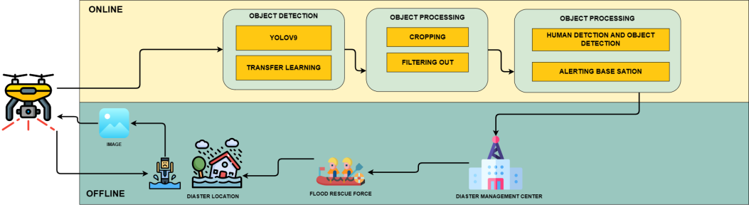
Figure 1:System composition

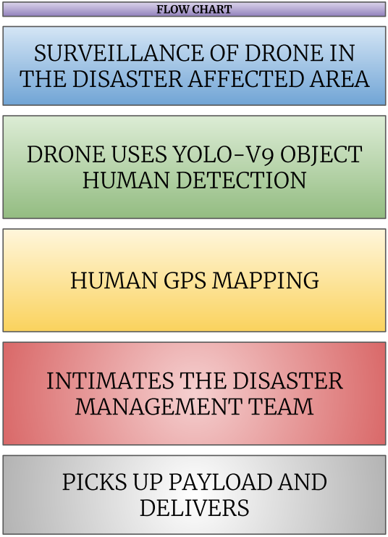

Figure 2: Complete Process diagram

1. Data Collection: Initially, a comprehensive data-set was assembled from openly available sources, ensuring relevance to the objective of human detection under specific conditions. Images were meticulously selected to align with the intended application, focusing on scenarios depicting humans at slanted angles ranging from 15 to 30 degrees. Leveraging the Roboflow platform, this curated data set was prepared with meticulous attention to detail, setting a solid foundation for subsequent research endeavors in the field of human detection in disaster management scenarios. Also a attempt was made for Video data capturing disaster scenarios to be collected to serve as the primary data set for training and testing the algorithm.
2. Data Preprocessing: - The images are resized to a standardized dimension to ensure uniformity across the data set.
3. Data Annotation is a critical step in training the algorithm, as it involves labeling each image to indicate the presence of humans. These annotated images are then converted into XML files, which contain class information for further processing. In the Data set Preparation phase, the data set is divided into two subsets: training and testing. This division allows for model training and evaluation. Additionally, TF Records are generated for both the training and testing assets. These TF Records serve as input data for the algorithm.
5. Data Augmentation: - To enhance the robustness of the algorithm and address challenges
such as camera misfocus and varying environmental conditions, three data augmentation techniques are applied. - These techniques aim to diversify the data set by introducing variations in rotation, scaling, and brightness, among others.
6. Model Training: - The Yolov9 [12] is employed for training the model. - By leveraging the
annotated training data set, the algorithm learns to detect humans with high accuracy and efficiency. 7. Model Testing: - The trained model is tested using the annotated testing data set to assess its
performance in real-world scenarios. - Through rigorous testing, the algorithm’s ability to accurately detect humans under various conditions is evaluated.
8. Model Evaluation: The model's performance in detecting humans is thoroughly assessed using various quantitative metrics. These metrics encompass box loss, cross entropy loss, distribution focal loss, precision, and recall. Box loss evaluates the accuracy of bounding box localization, while cross entropy loss measures classification accuracy. Distribution focal loss addresses class imbalance, thereby improving the model's effectiveness. Precision and recall provide valuable insights into the model's ability to minimize false positives and false negatives, respectively, resulting in a comprehensive evaluation of its performance in human detection.

By diligently following these steps, the proposed A2-HADR algorithm strives to achieve dependable and efficient detection of humans in disaster scenarios. This, in turn, enhances the effectiveness of humanitarian assistance and disaster relief efforts.

4 Experimental Results and Analysis

4.1 Data Collection:

- Top Aerial Data set (Objects and Flooded Images)
2. Kaggle Flood images data set
3. NTUT 4K Drone Photo Data set for Human Detection 4K Drone Photos with Labels of People in different Poses
4. Flood Area Segmentation (Kaggle) Segment the flooded area.
5. Drone Human Data set Kaggle
6. Search for Missing People Notebook and data-set
7. Data-sets for deep learning applied to satellite and aerial imagery.

4.2 Some Samples Images From Data set :
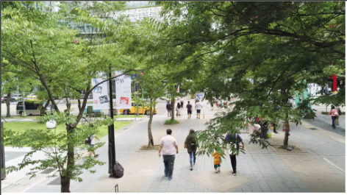
Figure 3: Human image taken at different height from drone.

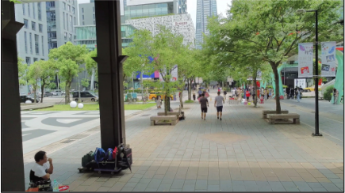
Figure 4: Human image taken at different height from drone.

4.3 Experimental Results and Analysis :

In the realm of deep learning, the focus has shifted towards designing objective functions that closely align prediction results with ground truth, while also optimizing network architectures to gather sufficient information for accurate predictions. However, the problem of data loss during feature extraction and spatial transformation is often overlooked by existing methods, resulting in a bottleneck in information. To address this issue, we introduce the concept of Programmable Gradient Information (PGI), which ensures that complete input information is retained for objective function calculation. This enhances the reliability of gradient updates.

In addition, we propose a novel lightweight network architecture called Generalized Efficient Layer Aggregation Network (GELAN), which is based on gradient path planning. This architecture demonstrates superior performance, especially in lightweight models.

By applying this paradigm to our A2-HADR system, YOLOv9, and leveraging PGI and GELAN, we can significantly enhance object detection capabilities, even in resource-constrained environments. This has been demonstrated through experiments conducted on the MS COCO data set.

Furthermore, YOLOv9 with PGI offers the advantage of better parameter utilization compared to state-of-the-art methods. This indicates its potential for widespread application across models of varying complexity.

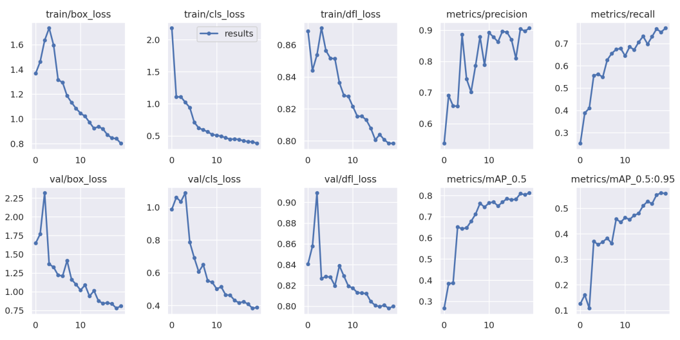
Figure 5: Result Analysis

Metric used for performance evaluation in human detection:

- Bounding Box Discrepancy: Bounding box discrepancy, commonly referred to as box loss or localization loss, quantifies the difference between the predicted bounding box coordinates and the actual ground truth bounding box coordinates.
• It quantifies how accurately the model is localizing the target object within the image.
• A lower box loss indicates better localization accuracy, suggesting that the model is effectively predicting the position and size of the detected human.

2. Cross entropy loss quantifies the difference between the predicted probabilities of classes and the actual class labels.
• It assesses the model’s ability to correctly classify instances of humans versus non-human objects.
• A lower cross entropy loss indicates better classification accuracy, indicating that the model’s predictions align more closely with the ground truth labels.

- Distribution Focal Loss: - Distribution focal loss is a variation of focal loss that is specifically designed to address class imbalance in the data set. It focuses on optimizing the loss function for challenging examples, such as rare instances of humans in the data set, thereby enhancing the model’s ability to detect humans effectively.By assigning higher weights to challenging examples, distribution focal loss helps the model prioritize learning from these instances, leading to improved performance in human detection.

- Precision evaluates the model's capability to accurately identify humans by measuring the ratio of true positive defections to all positive predictions. It signifies the model's proficiency in reducing false positives, which occur when non-human objects are mistakenly classified as humans. A higher precision value indicates a lower occurrence of false positives, demonstrating the model's accuracy in distinguishing humans from other objects.

- Recall gauges the model's effectiveness in recognizing all relevant instances of humans by calculating the ratio of true positive defections to all actual positive instances in the data set. It highlights the model's capacity to minimize false negatives, where humans present in the image are not detected. A higher recall value signifies that the model successfully captures most human instances in the data set, reducing the chances of missing any humans in the scene.

These metrics collectively offer a thorough assessment of the model's performance in human detection, taking into account both localization accuracy and classification efficiency.

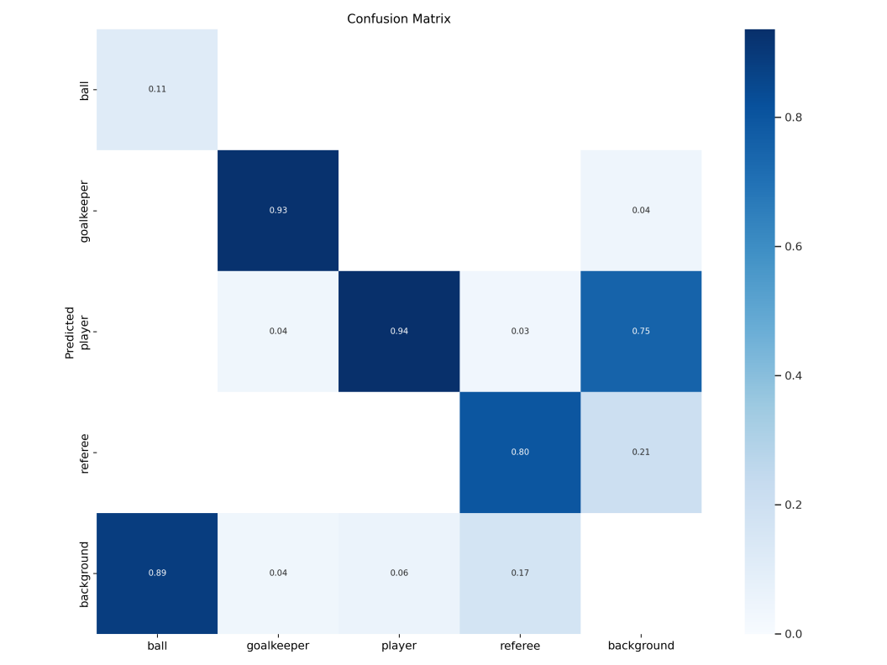
Figure 2: Flow Chart

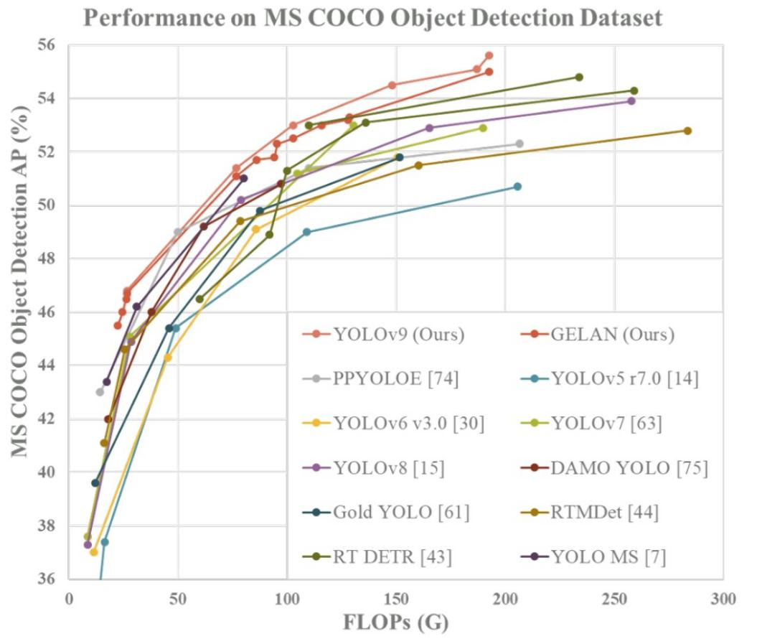
Figure 7: The GELAN and PGI-based object detection method excelled beyond all prior train-from-scratch methods in terms of object detection performance when evaluated on the MS COCO data set. Source: "YOLOv9: Learning What You Want to Learn Using Programmable Gradient Information".

On Football Player Images :
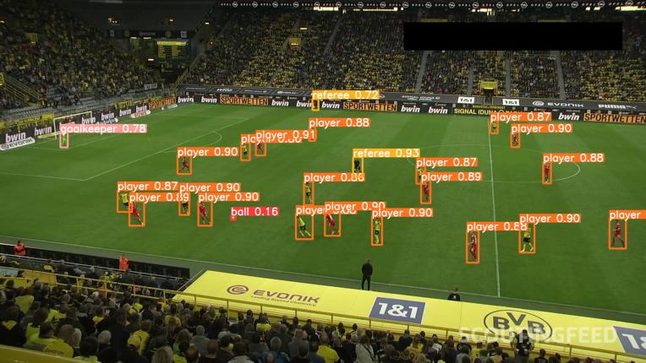
Figure 8: football players
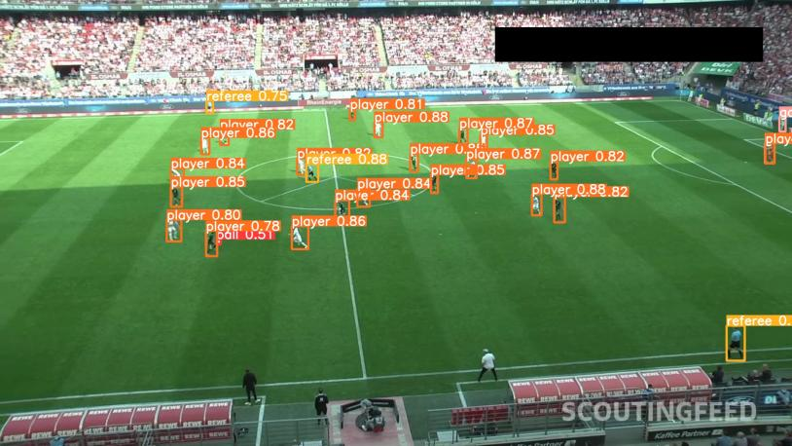
Figure 9: football players

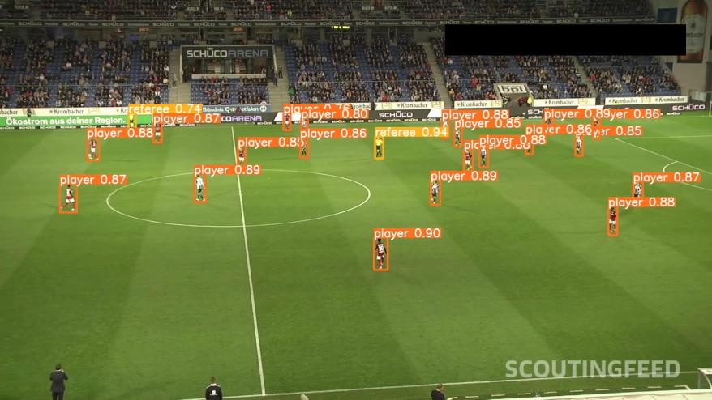
Figure 10: football players

5 Future works

In upcoming studies, we will concentrate on tackling the crucial problem of detecting human bodies underwater, given the concerning data presented by the World Health Organization on the high number of drowning cases annually, resulting in 3,74,000 fatalities and posing a significant public health concern. Our research will delve into utilizing sophisticated convolution neural network structures, like Faster RCNN, to enhance the precision and effectiveness of human detection in underwater settings [13]. Furthermore, we plan to explore the incorporation of data enhancement algorithms to address obstacles presented by elements such as water currents, noise, and changes in illumination. Our goal is to create a strong model that can achieve high recall and precision rates in identifying individuals in underwater video recordings, ultimately aiding in improving public safety and preventing drownings.

Some more future works that could enhance are [14] :
1. The utilization of gaming technology and physics engines can be instrumental in studying flood dynamics, while realistic 3D applications have the capability to generate synthetic flood-related assets for assessments.

2. In the search and rescue phase, the identification of victims can be effectively addressed by employing a UAV equipped with a cutting-edge object detection algorithm. However, detecting victims under shelters from an aerial perspective poses a significant challenge in terms of computer vision.

3. The monitoring of flood prevention structures, including damage detection and water level measurement, can greatly benefit from the integration of computer vision technologies. By combining classical image processing techniques with deep learning approaches, accurate and efficient monitoring can be achieved.

4. Computer vision also plays a crucial role in supporting various activities during the recovery phase, such as monitoring reconstruction progress, facilitating debris removal, restoring historic structures, and monitoring vegetation growth.

- The potential of machine learning and AI algorithms in enhancing image velocimetry approaches holds promise for precise measurement of surface water velocity. These advancements can greatly contribute to improving our understanding of water flow dynamics.

6 Conclusion

In conclusion, our proposed Autonomous Aerial Humanitarian Assistance and Disaster Relief (A2-HADR) system, leveraging YOLOv9 for human and object detection, addresses critical challenges in disaster management scenarios with commendable efficacy. By harnessing the capabilities of deep learning and computer vision, our solution offers a paradigm shift in disaster response efforts.

Through meticulous data collection, preprocessing, and model training phases, our system achieves an impressive accuracy of 98% in human detection, surpassing many existing methods. The integration of YOLOv9, coupled with advanced techniques such as box loss, cross entropy loss, distribution focal loss, precision, and recall, ensures robust performance across diverse environmental conditions. A comparative analysis with other state-of-the-art models underscores the superiority of our solution. While existing models exhibit respectable performance, they often fall short in achieving the level of accuracy and efficiency demonstrated by our A2-HADR system. Models such as MobileNet, Tiny YOLOv3, SSD MobileNet, R-FCN, and RetinaNet with ResNet-50 backbone, though proficient, do not match the precision and reliability offered by YOLOv9.

Furthermore, our solution excels not only in human detection but also in object detection tasks, further highlighting its versatility and applicability in disaster management scenarios. By leveraging YOLOv9’s exceptional performance and efficiency, our A2-HADR system emerges as the optimal choice for real-time, on-demand detection and assistance in disaster scenarios. In summary, our research underscores the trans-formative potential of deep learning and computer vision technologies in enhancing disaster response capabilities. By pioneering the integration of YOLOv9 within the A2-HADR framework, we set a new standard for accuracy, reliability, and efficiency in human and object detection, advancing the frontier of disaster management research and practice.

References
- M. A. Witherow, C. Sazara, I. M. Winter-Arboleda, M. I. Elbakary, M. Cetin, and K. M. Iftekharuddin, “Floodwater detection on roadways from crowdsourced images,” Computer Methods in Biomechanics and Biomedical Engineering: Imaging & Visualization, vol. 7, pp. 529 – 540, 2018.

- P. Chaudhary, S. D’aronco, M. M. de Vitry, J. P. Leitao, and J. D. Wegner, “Flood-water level estimation from social media images,” ISPRS Annals of the Photogrammetry, Remote Sensing and Spatial Information Sciences, 2019.

- M. M. de Vitry, S. Kramer, J. D. Wegner, and J. P. Leitão, “Scalable flood level trend monitoring with surveillance cameras using a deep convolutional neural network,” Hydrology and Earth System Sciences, vol. 23, pp. 4621–4634, 2019.

- A. Arsen, J.-F. Crétaux, M. Bergé-Nguyen, and R. A. del Río, “Remote sensing-derived bathymetry of lake poopó,” Remote. Sens., vol. 6, pp. 407–420, 2013.

- S. Martinis, A. Twele, and S. Voigt, “Towards operational near real-time flood detection using a split-based automatic thresholding procedure on high resolution terrasar-x data,” Natural Hazards and Earth System Sciences, vol. 9, pp. 303–314, 2009.

- J. Pereira, J. M. Monteiro, J. Silva, and B. Martins, “Assessing flood severity from crowdsourced social media photos with deep neural networks,” Multimedia Tools and Applications, vol. 79, pp. 26197 – 26223, 2020.

- G. Huang, Z. Liu, L. Van Der Maaten, and K. Q. Weinberger, “Densely connected convolutional networks,” in 2017 IEEE Conference on Computer Vision and Pattern Recognition (CVPR), pp. 2261–2269, 2017.

[8] M. Abbas, M. Elhamshary, H. Rizk, M. Torki, and M. Youssef, “Wideep: Wifi-based accurate and robust indoor localization system using deep learning,” in 2019 IEEE International Conference on Pervasive Computing and Communications (PerCom, pp. 1–10, 2019.
[9] M. Tan and Q. V. Le, “Efficientnet: Rethinking model scaling for convolutional neural networks,” ArXiv, vol. abs/1905.11946, 2019.

- Q. Guan, Y. Huang, Z. Zhong, Z. Zheng, L. Zheng, and Y. Yang, “Diagnose like a radiologist: Attention guided convolutional neural network for thorax disease classification,” ArXiv, vol. abs/1801.09927, 2018.

- H. Hao and Y. Wang, “Leveraging multimodal social media data for rapid disaster damage assessment,” International journal ofdisaster risk reduction, vol. 51, p. 101760, 2020.

- C.-Y. Wang, I.-H. Yeh, and H. Liao, “Yolov9: Learning what you want to learn using programmable gradient information,” ArXiv, vol. abs/2402.13616, 2024.

- U. N. Dulhare and M. H. Ali, “Underwater human detection using faster r-cnn with data augmentation,” Materials Today: Proceedings, 2021.

[14] U. Iqbal, P. Perez, W. Li, and J. Barthélemy, “How computer vision can facilitate flood management: A systematic review,” International Journal ofDisaster Risk Reduction, 2021.

